**Lab Exercise 3- Working with Git Rebase**

**Lab Exercise: Git Rebase**

This exercise demonstrates the use of git rebase in a scenario where no conflicts occur.

**Objective**

1. Learn how to rebase branches when there are no conflicting changes.
2. Understand the clean, linear history created by git rebase.

**Prerequisites**

1. Initialize a Git repository:

git init git-rebase-lab

cd git-rebase-lab





**Step-by-Step Instructions**

**1. Set Up the Repository**

1. Create the main branch and make the initial commit:

echo "Line 1 from main branch" > file.txt

git add file.txt



git commit -m "Initial commit: Add Line 1 from main branch"

1. Create a new branch feature-branch:

git checkout -b feature-branch



1. Add a new line to file.txt in feature-branch:

echo "Line 2 from feature branch" >> file.txt

git add file.txt

git commit -m "Add Line 2 from feature branch"

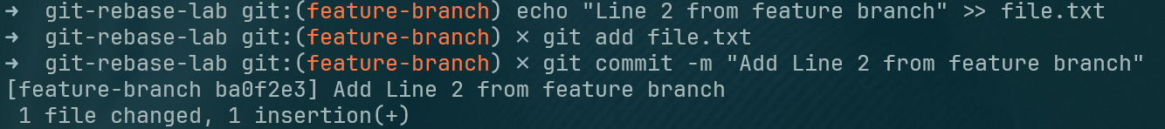

1. Switch back to the main branch and add another line:

git checkout main



echo "Line 3 from main branch" >> file.txt

git add file.txt

git commit -m "Add Line 3 from main branch"

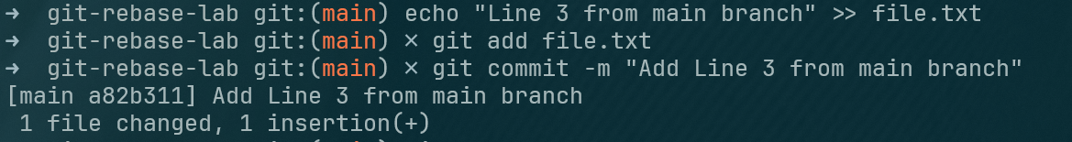

**2. Rebase feature-branch onto main**

1. Switch to feature-branch:

git checkout feature-branch



1. Rebase feature-branch onto main:

git rebase main

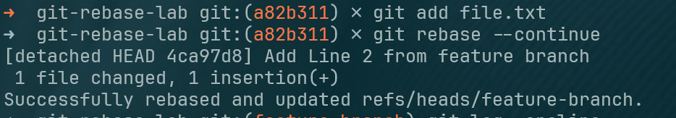

1. Git will replay the commit from feature-branch onto the main branch. Since there are no conflicts, the rebase completes automatically.

**3. Verify the Rebase**

1. View the commit history:

git log –oneline

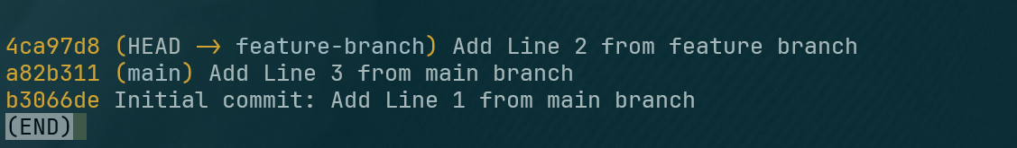

git log --oneline –graph

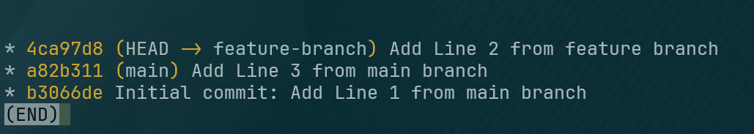

Example output:

* Add Line 2 from feature branch

* Add Line 3 from main branch

* Initial commit: Add Line 1 from main branch

1. Check the contents of file.txt:

cat file.txt

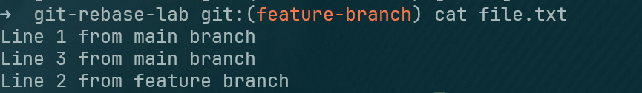

Output:

Line 1 from main branch

Line 3 from main branch

Line 2 from feature branch